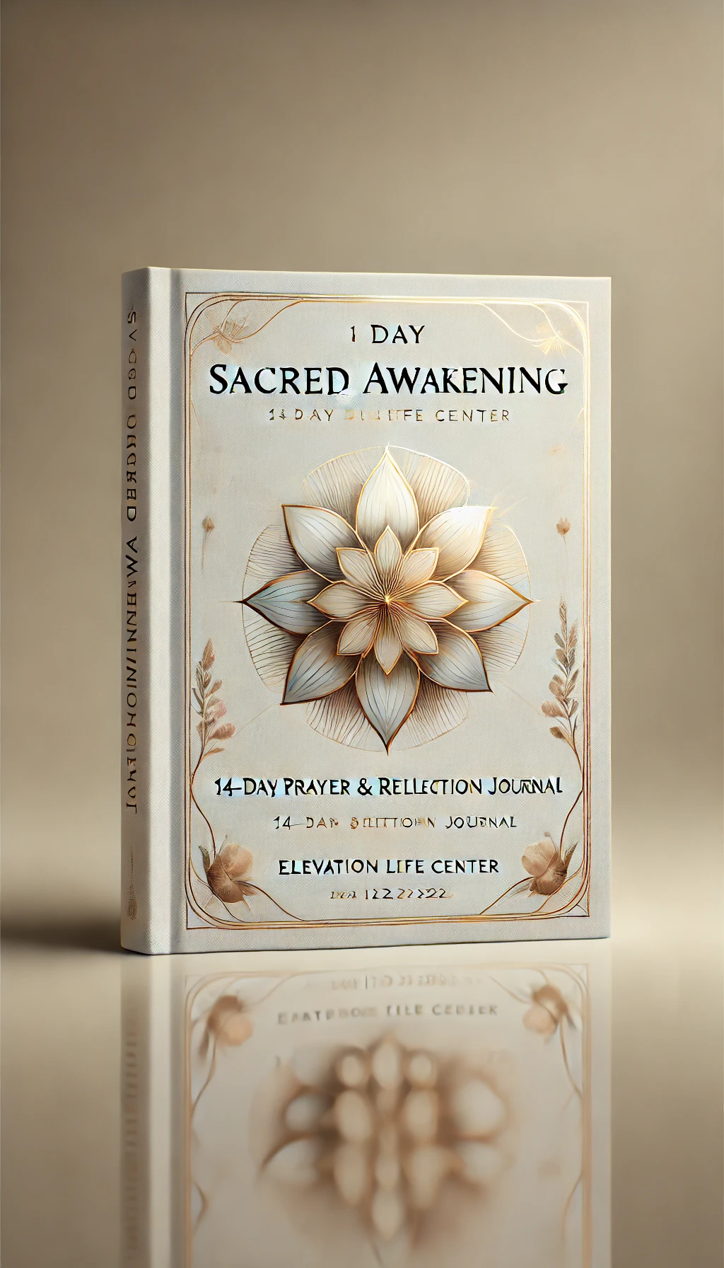

**Sacred Awakening: A 14-Day Daniel Fast Guide**

**Elevation Life Center | January 12-26, 2025**  
**Website:** [**elifecenter.com**](http://elifecenter.com)

**Introduction**

Starting 2025, Elevation Life Center invites you to join in 14 days of prayer and fasting from January 12-26. This is a time of spiritual renewal and a journey towards a deeper connection with God. Through fasting, we set aside the physical to focus on the spiritual, allowing God to awaken our hearts and minds to His purposes.

**Prayer** is our first priority because it connects us to God’s power and presence. Prayer is as vital to our spirit as oxygen is to our lungs, and God uses it to guide us in His path for our lives.

**Why Pray?**

Extraordinary times call for extraordinary prayers. We are called to spend time with God, just as we would with someone we deeply love. Jesus prayed, and He calls us to pray too, so that we may understand His will and fulfill it through the power of the Holy Spirit.

**"When you pray, go into your room, close the door and pray to your Father, who is unseen."** (Matthew 6:6)

**Why Fast?**

Throughout the Bible, God’s people fasted as a way to seek His guidance, receive breakthrough, and deepen their faith. Fasting shifts our focus from the physical to the spiritual, opening our hearts for God’s will and His plans.

**"When you fast, do not look somber as the hypocrites do...your Father, who sees what is done in secret, will reward you."** (Matthew 6:16-18)

**What is Fasting?**

Fasting involves willingly abstaining from certain foods to draw closer to God. It’s about surrendering the physical to focus on the spiritual, creating space for God to work in and through us.

**Is Fasting Biblical?**

From Moses to Jesus, many heroes of faith fasted. Fasting was not just for their time—it’s for today as well. Jesus said, **“When you fast…”** (Matthew 6:16), indicating that fasting is a normal part of Christian life.

**The Daniel Fast**

As a church, we will follow the **Daniel Fast** for 14 days. This fast is based on the prophet Daniel’s diet in the Bible and focuses on fruits, vegetables, and water, eliminating processed foods, meats, and sugars.

**Foods to Eat:**

* **Fruits:** Apples, bananas, berries, etc.
* **Vegetables:** Broccoli, carrots, lettuce, etc.
* **Legumes:** Lentils, beans, etc.
* **Whole Grains:** Brown rice, oats, quinoa, etc.
* **Nuts & Seeds:** Sunflower seeds, almonds, etc.
* **Quality Oils:** Olive, peanut, and sesame oil.
* **Tofu & Soy Products**

**Foods to Avoid:**

* Meats and animal products
* Dairy
* Deep-fried foods
* Sugar and artificial sweeteners
* Refined foods and processed items

**Preparing for the Fast**

**Spiritual Preparation**

1. **Pray** daily leading up to the fast, asking God to prepare your heart.
2. **Read Bible verses on fasting**, such as Isaiah 58 and Matthew 4:1-11.
3. **Keep a journal** to record your prayers and reflections.
4. **Set prayer goals** for your fast.
5. **Find a prayer partner** for support and accountability.

**Physical Preparation**

1. **Ease into the fast** by reducing intake of restricted foods.
2. **Plan meals** to stay aligned with the Daniel Fast.
3. **Create a grocery list** for foods permitted on the fast.
4. **Prepare your kitchen** with the tools you’ll need.
5. **Cook and freeze meals** for busy days.

**Daily 60-Second Prayers**

During each day of the fast, spend at least 60 seconds in focused prayer on specific themes to strengthen your journey.

1. **Day 1:** Pray for God’s guidance.
2. **Day 2:** Pray for spiritual strength.
3. **Day 3:** Pray for humility.
4. **Day 4:** Pray for discernment.
5. **Day 5:** Pray for forgiveness.
6. **Day 6:** Pray for unity.
7. **Day 7:** Pray for deeper faith.
8. **Day 8:** Pray for patience.
9. **Day 9:** Pray for joy.
10. **Day 10:** Pray for wisdom.
11. **Day 11:** Pray for strength in trials.
12. **Day 12:** Pray for peace.
13. **Day 13:** Pray for endurance.
14. **Day 14:** Pray for continued growth.

**Conclusion**

This 14-day fast is a time of **sacred awakening**. As we pray and fast together, may we experience God’s presence, power, and purpose in new and profound ways. Let’s draw close to God and commit this time as a church to seek Him wholeheartedly.

**“Draw near to God, and He will draw near to you.”** (James 4:8)

**For more resources and support during the fast, visit** [**elifecenter.com**](http://elifecenter.com)

Feel free to adjust or add sections as needed. This manual can serve as a comprehensive guide for church members to engage in the Sacred Awakening fast with purpose and direction. Let me know if you’d like any additional sections or specific details.

**Sacred Awakening 14-Day Journal**

**Elevation Life Center | January 12-26, 2025**

**How to Use This Journal**

Each day, take time to read the scripture, reflect on the prompt, and write your thoughts. Let this journal be a place where you pour out your heart, seek God, and capture His responses.

**Day 1: Seeking God’s Guidance**

**Scripture:** *“Trust in the Lord with all your heart and lean not on your own understanding.”* (Proverbs 3:5)

**Prayer Focus:** Ask God for clear direction as you begin the fast. Surrender any plans or desires that may conflict with His will for your life.

**Reflection Prompt:** Where do you need God’s guidance most right now? How can you rely more fully on Him in this area?

**Journal:**

**Day 2: Building Spiritual Strength**

**Scripture:** *“The Lord is my strength and my shield; my heart trusts in him, and he helps me.”* (Psalm 28:7)

**Prayer Focus:** Pray for spiritual strength and resilience as you let go of familiar comforts and focus on God.

**Reflection Prompt:** What personal challenges are you bringing into this fast? How can God’s strength help you overcome them?

**Journal:**

**Day 3: Embracing Humility**

**Scripture:** *“Humble yourselves before the Lord, and he will lift you up.”* (James 4:10)

**Prayer Focus:** Ask God to reveal any areas of pride and help you adopt a spirit of humility in your interactions and decisions.

**Reflection Prompt:** In what ways can you show more humility in your relationship with God and others?

**Journal:**

**Day 4: Seeking Discernment**

**Scripture:** *“If any of you lacks wisdom, you should ask God… and it will be given to you.”* (James 1:5)

**Prayer Focus:** Pray for wisdom and clarity, asking God to sharpen your discernment in every area of your life.

**Reflection Prompt:** Where do you need wisdom in your life right now? What decision or situation requires God’s guidance?

**Journal:**

**Day 5: Offering Forgiveness**

**Scripture:** *“Forgive as the Lord forgave you.”* (Colossians 3:13)

**Prayer Focus:** Ask God to help you release any unforgiveness and show grace to others, just as He has shown grace to you.

**Reflection Prompt:** Are there people or situations you need to forgive? How can releasing this improve your relationship with God?

**Journal:**

**Day 6: Praying for Unity**

**Scripture:** *“Make every effort to keep the unity of the Spirit through the bond of peace.”* (Ephesians 4:3)

**Prayer Focus:** Pray for unity in your family, church, and community. Ask God to strengthen bonds and bring harmony.

**Reflection Prompt:** What role can you play in creating unity? How can you be a peacemaker in your relationships?

**Journal:**

**Day 7: Deepening Faith**

**Scripture:** *“Now faith is confidence in what we hope for and assurance about what we do not see.”* (Hebrews 11:1)

**Prayer Focus:** Ask God to increase your faith and help you trust in His promises, even when you cannot see the outcome.

**Reflection Prompt:** What areas of your life require more faith? How can you choose trust over fear?

**Journal:**

**Day 8: Cultivating Patience**

**Scripture:** *“Be completely humble and gentle; be patient, bearing with one another in love.”* (Ephesians 4:2)

**Prayer Focus:** Pray for patience in your circumstances and with others. Ask God to help you slow down and wait on Him.

**Reflection Prompt:** How can you show more patience this week? What situations test your patience the most?

**Journal:**

**Day 9: Choosing Joy**

**Scripture:** *“The joy of the Lord is your strength.”* (Nehemiah 8:10)

**Prayer Focus:** Ask God to fill you with joy that goes beyond circumstances, drawing your strength from His presence.

**Reflection Prompt:** What brings you joy in your walk with God? How can you focus on these things, even during challenges?

**Journal:**

**Day 10: Growing in Wisdom**

**Scripture:** *“Teach us to number our days, that we may gain a heart of wisdom.”* (Psalm 90:12)

**Prayer Focus:** Pray for wisdom to use your time, resources, and abilities for God’s glory.

**Reflection Prompt:** How can you live with a wise and eternal perspective? What does God’s wisdom look like in your daily life?

**Journal:**

**Day 11: Finding Strength in Trials**

**Scripture:** *“I can do all this through him who gives me strength.”* (Philippians 4:13)

**Prayer Focus:** Ask for God’s strength to sustain you through trials, remembering that He is always with you.

**Reflection Prompt:** What current trial do you need strength for? How can you rely on God rather than your own efforts?

**Journal:**

**Day 12: Seeking Peace**

**Scripture:** *“And the peace of God, which transcends all understanding, will guard your hearts and your minds in Christ Jesus.”* (Philippians 4:7)

**Prayer Focus:** Pray for God’s peace to calm your heart and mind, trusting in His plans for you.

**Reflection Prompt:** Where do you need peace? How can you make room for God’s peace in your daily life?

**Journal:**

**Day 13: Building Endurance**

**Scripture:** *“Let us run with endurance the race God has set before us.”* (Hebrews 12:1)

**Prayer Focus:** Pray for endurance to stay committed to the fast and to continue seeking God, even in difficult times.

**Reflection Prompt:** How can you cultivate endurance in your faith? What can help you stay faithful when challenges arise?

**Journal:**

**Day 14: Continuing the Journey**

**Scripture:** *“I press on toward the goal to win the prize for which God has called me.”* (Philippians 3:14)

**Prayer Focus:** Pray for a continued passion to seek God after the fast, and for the strength to follow His calling.

**Reflection Prompt:** How can you continue pursuing God after this fast ends? What goals or commitments will you carry forward?

**Journal:**

**Closing Reflection**

Congratulations on completing the 14-Day Daniel Fast! Take some time to reflect on the past two weeks. What did God reveal to you? How have you changed? Write down any final thoughts, commitments, or prayers as you move forward in your walk with God.

**Journal:**